**Present: Members of Hockwold cum Wilton Parish Council Lode Advisory Committee**

Cllr Turner, Cllr John, Mr C. Smith and Mr Derbyshire

**Others in attendance**

Parish Clerk Ms H. Cox

4 members of the public

**OPEN FORUM**

* Charles Ratchford attended and spoke about the BOAT information appeal for a section of Church Lane and Nursery Lane. He discussed the previous/historical works that have been done on the spinney (top triangle of the Lode property) and alerted the LAC to power lines that are in danger due to branches from trees on the spinney. Mr Ratchford also enquired into the upkeep of the bench area of the spinney and the disrepair of the road directly out front of his property adjacent from the bench area of the spinney.

**1. To receive and approve apologies for absence.** Apologies given for Cllr Sismey and Mr Moss

**2. To receive any declarations of interest from Members & consider requests for dispensation.** No declarations of interest were submitted. No requests for dispensation were submitted.

***Members are invited to declare disclosable pecuniary interests and other interests in items on the agenda as required by the Hockwold cum Wilton Parish Council Code of Conduct for Members and by the Localism Act 2011.***

**3. To schedule meetings of Lode Advisory Committee for the year 2018-2019** The members discussed the best schedule of meetings to allow seasonal discussions on maintenance of the Lode and budget submissions to the Hockwold Parish Council. It was proposed to meet four times a year. (seasonally) The following dates for the next year included. Proposed by Cllr Johns. Seconded by Mr Smith. Agreed by all present.

13th September 2018

11th October 2018

14th March 2019

13th June 2019

**4. To decide on a proposal maintenance plan for the Lode common land for the year 2018-2019** The following schedule was created and proposed. It was also proposed that grass cuttings with be distributed under the canopy as not to make piles or an unsightly mess, the branches to be disposed of as needed, litter to be collected as needed and the end result is to do the minimum works and focus on maintenance to keep accessible with a focus on keeping it as it is now. Proposed by Cllr Johns. Seconded by Mr Smith. Agreed by all present.



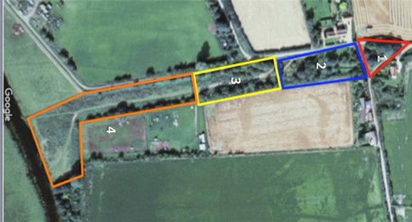

**5. To organize research and gather information on bylaws and enforcement for bylaws** Clerk to organize and research bylaws and bring to the October LAC meeting for discussion.

**6. To set a date for LAC budget proposal to be submitted to the full Hockwold cum Wilton Parish Council for the year 2019-2020** Proposed to submit budget proposal to the full Parish Council in time for their November meeting. Proposed by Cllr Johns. Seconded by Mr Derbyshire. Agreed by all.

**7. To confirm date and time of the next LAC Meeting Thursday 13th September 2018, 6.30 pm** Confirmed

Distribution:

One copy to each member of the LAC and Hockwold cum Wilton Parish Councillors and one copy for the web-site.